**Internship Report: Stock Trading Simulation**

**1. Introduction**

The Stock Trading Simulation project is a web-based application designed to simulate stock trading for users. It provides a platform for users to explore stock market data, perform stock-related calculations, and visualize trends through interactive charts. The project was developed during my internship to enhance my skills in front-end web development, data visualization, and user interface design.

**2. Background**

The stock market is a dynamic and data-driven environment, and investors often need tools to analyze and track stock performance. The Stock Trading Simulation project was conceived to address this need by providing a user-friendly platform for stock market enthusiasts. The project leverages modern web technologies, including:

Frontend: HTML, CSS, JavaScript, Chart.js

Data Visualization: Interactive charts for stock price trends

Local Storage: For saving user data and transactions

**3. Learning Objectives**

The primary objectives of this internship were:

To gain hands-on experience in front-end web development.

To learn and implement data visualization using Chart.js.

To develop a user-friendly interface for stock trading simulation.

To enhance problem-solving skills by addressing challenges during development.

To create a functional and interactive application for stock market analysis.

**4. Activities and Tasks**

During the internship, I completed the following tasks:

Project Planning:

Defined project scope and requirements.

Designed the user interface and workflow.

Frontend Development:

Created the layout using HTML and CSS.

Added interactivity using JavaScript.

Integrated Chart.js for visualizing stock data.

**User Authentication:**

Implemented a local login/signup system using JavaScript.

Added functionality for profile management and password recovery.

Stock Simulation:

Developed a stock trading system with buy/sell functionality.

Implemented a transaction history feature.

**Testing and Debugging:**

Tested the application for responsiveness and functionality.

Fixed bugs related to user authentication and UI interactions.

**5. Skills and Competencies**

Through this project, I developed the following skills:

Technical Skills:

Proficiency in HTML, CSS, and JavaScript.

Experience with Chart.js for data visualization.

Knowledge of local storage for saving user data.

**Soft Skills:**

Problem-solving and debugging.

Time management and task prioritization.

Collaboration and communication (if working in a team).

**6. Feedback and Evidence**

**Feedback:**

Received positive feedback from mentors on the application's design and user experience.

Suggestions for improvement included integrating real-time data APIs and adding more features like portfolio management.

**Evidence:**

**The live application hosted on vercel:-**

<https://vercel.com/aishu71997s-projects/portfolio-simulator-e86e/FBnM3PbqVJgaheWnNWdUyy1RvDAi>

**Source code repository on GitHub:-**

<https://github.com/aishu71997/portfolio-simulator>

**7. Challenges and Solutions**

**Challenge:** Implementing dynamic charts with Chart.js.

**Solution:** Used Chart.js to create interactive pie and bar charts, updating them dynamically with stock data.

**Challenge:** Managing user data without a backend.

**Solution:** Used local storage to save and load user data, including profile information and transaction history.

**Challenge**: Ensuring a responsive and user-friendly design.

Solution: Tested the application on multiple devices and screen sizes to ensure compatibility.

**8. Outcomes and Impact**

**Outcomes:**

Successfully developed a functional stock trading simulation application.

Gained practical experience in front-end development and data visualization.

Improved problem-solving and debugging skills.

**Impact:**

The application can be used by stock market enthusiasts to simulate trading and analyse stock data.

The project demonstrates my ability to develop real-world applications using modern technologies.

**9. Conclusion**

The Stock Trading Simulation project was a valuable learning experience during my internship. It allowed me to apply my knowledge of front-end development and data visualization to create a practical and user-friendly application. The challenges I faced during the project helped me grow as a developer and improved my problem-solving skills. Moving forward, I plan to integrate real-time data APIs and add more features, such as portfolio management and advanced analytics, to enhance the application's functionality.

**Appendices**

**Screenshots of the Application:**

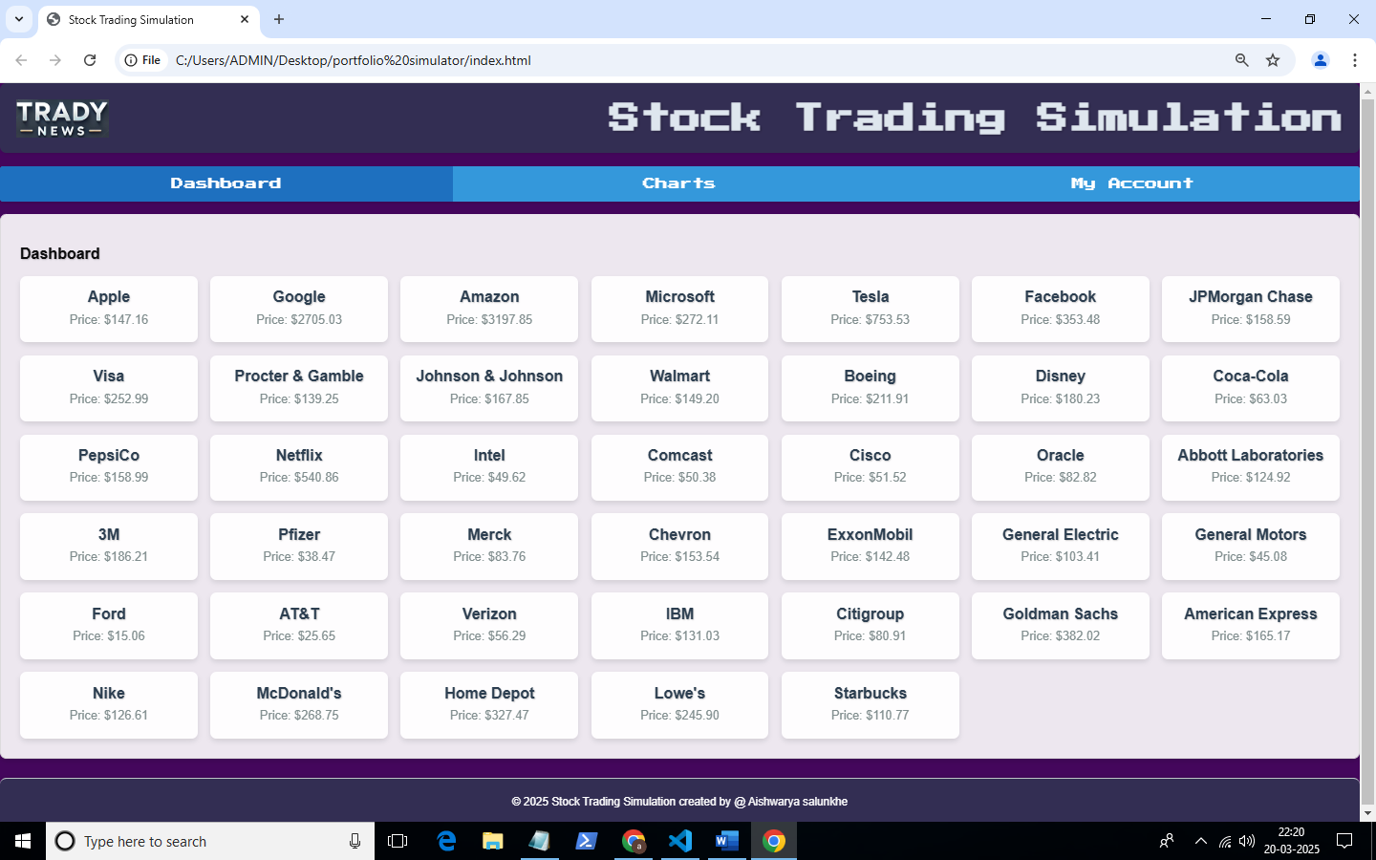

**Dashboard Page**



**Charts Page**

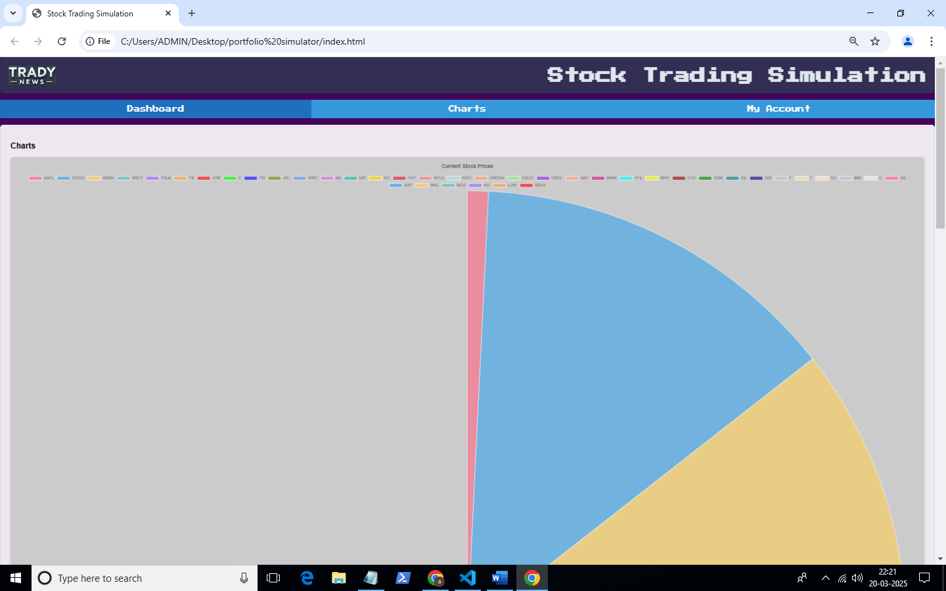

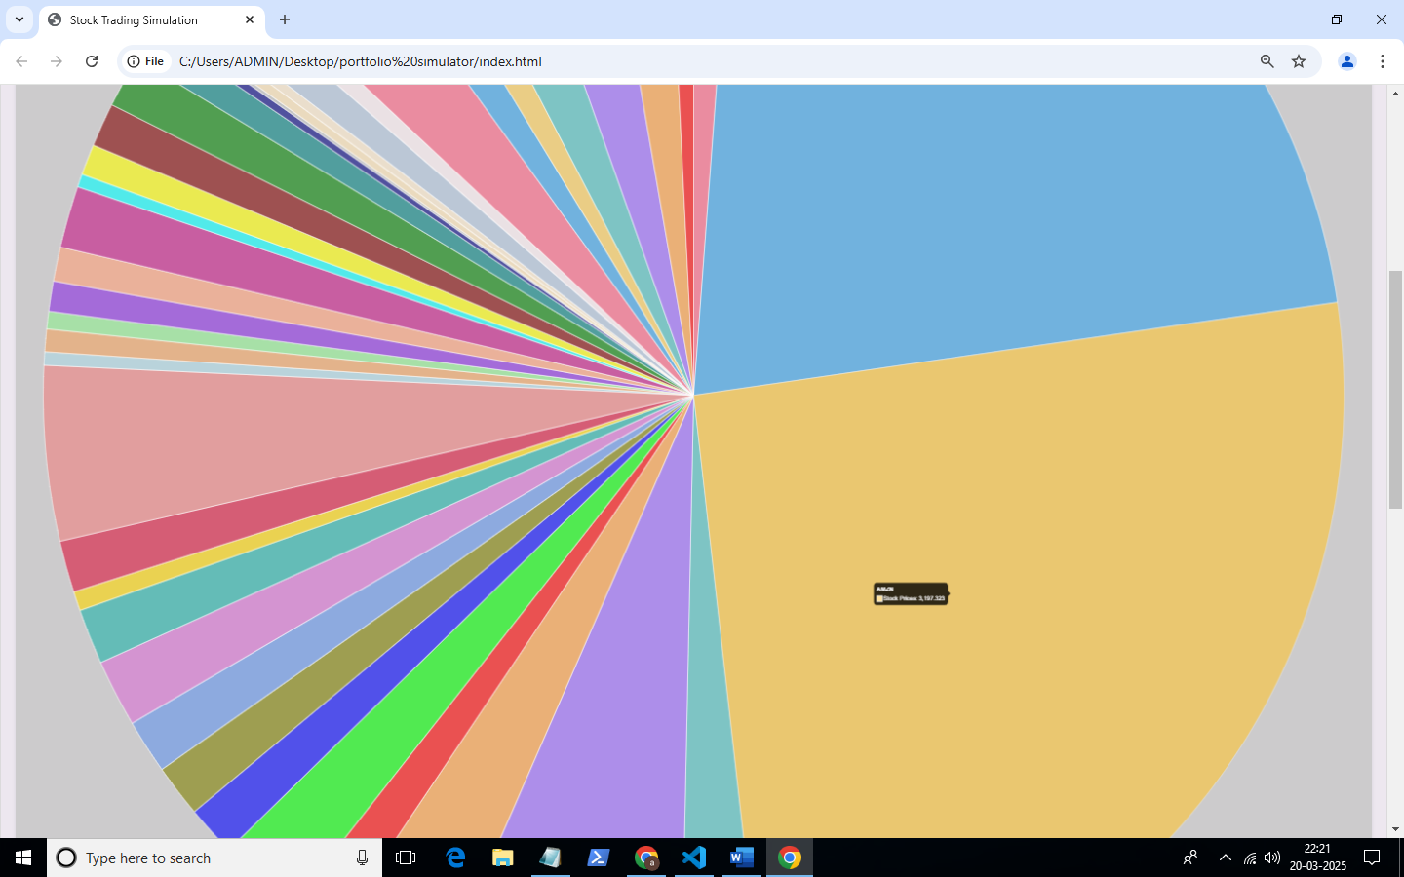

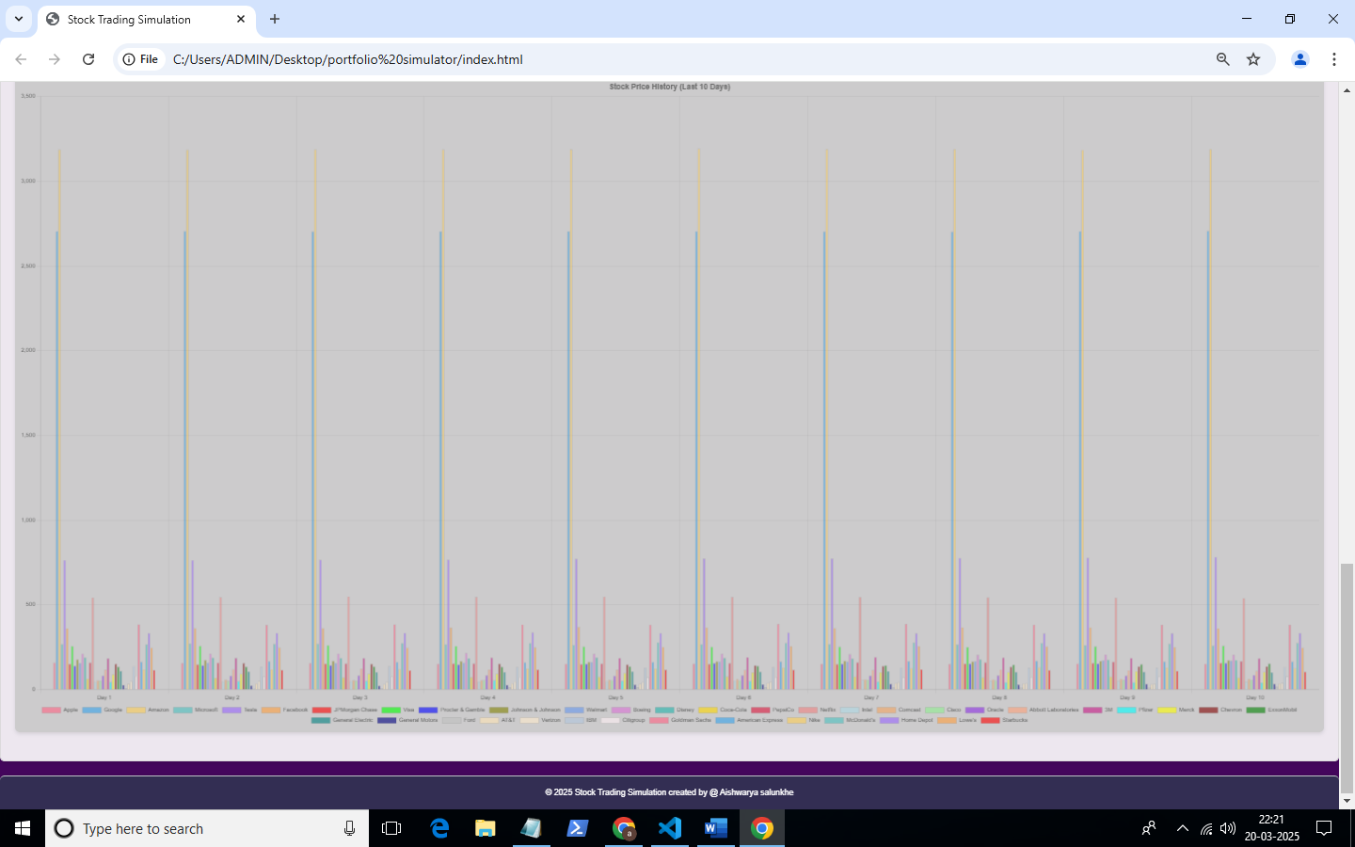

**My Account Page**

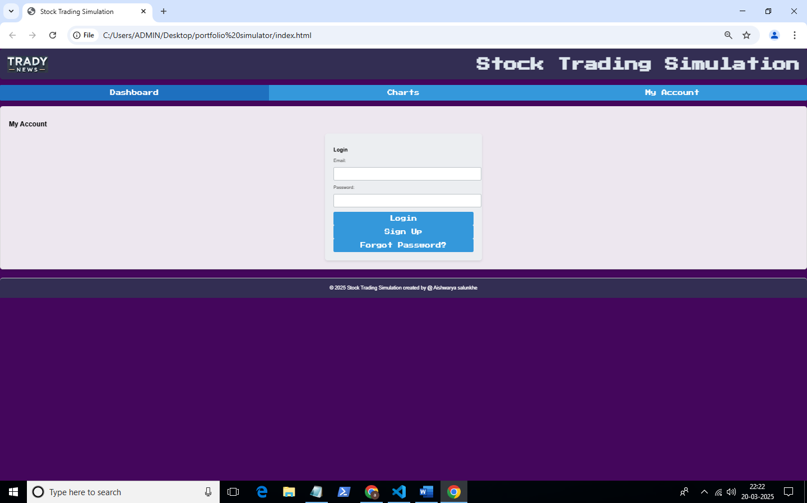

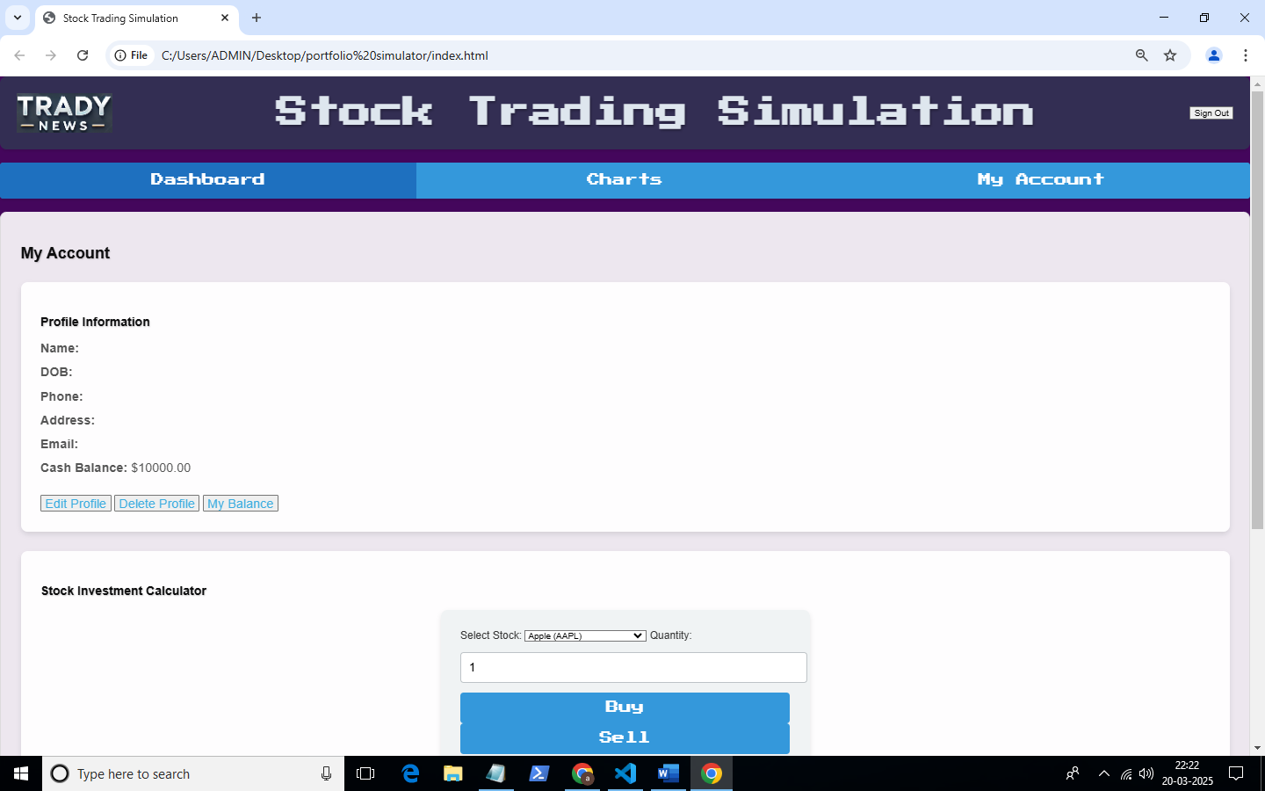

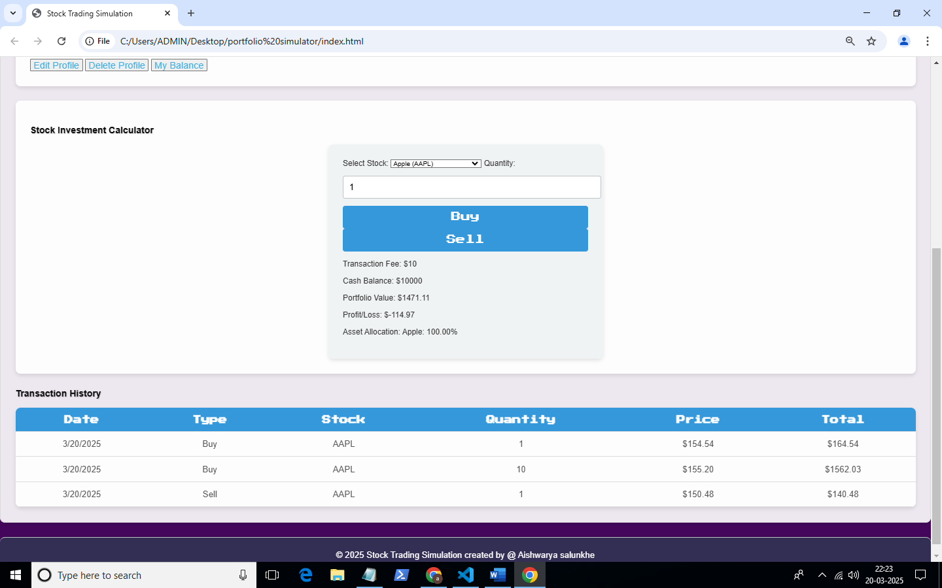

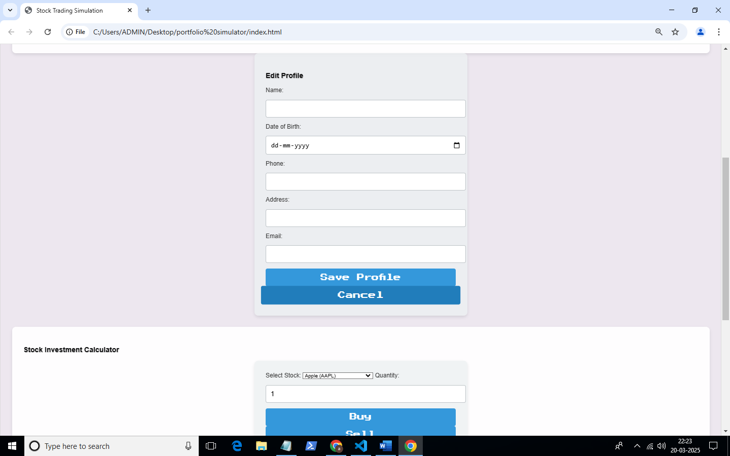

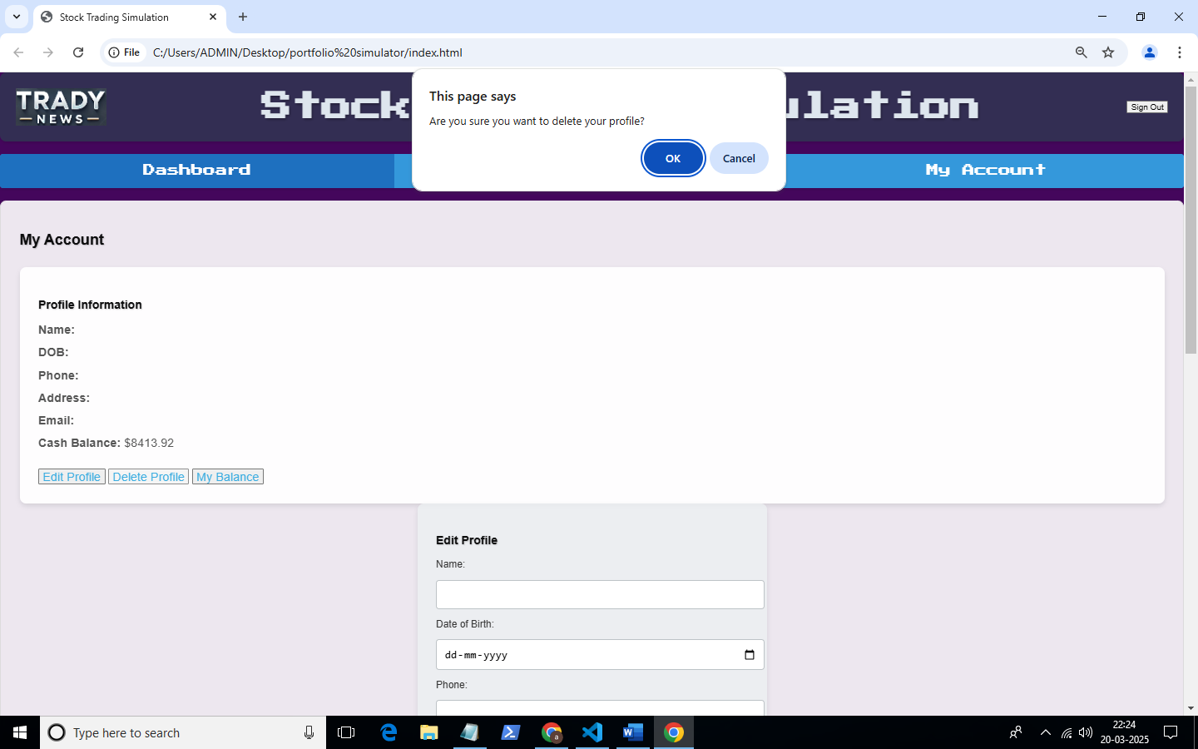

**my balance page**

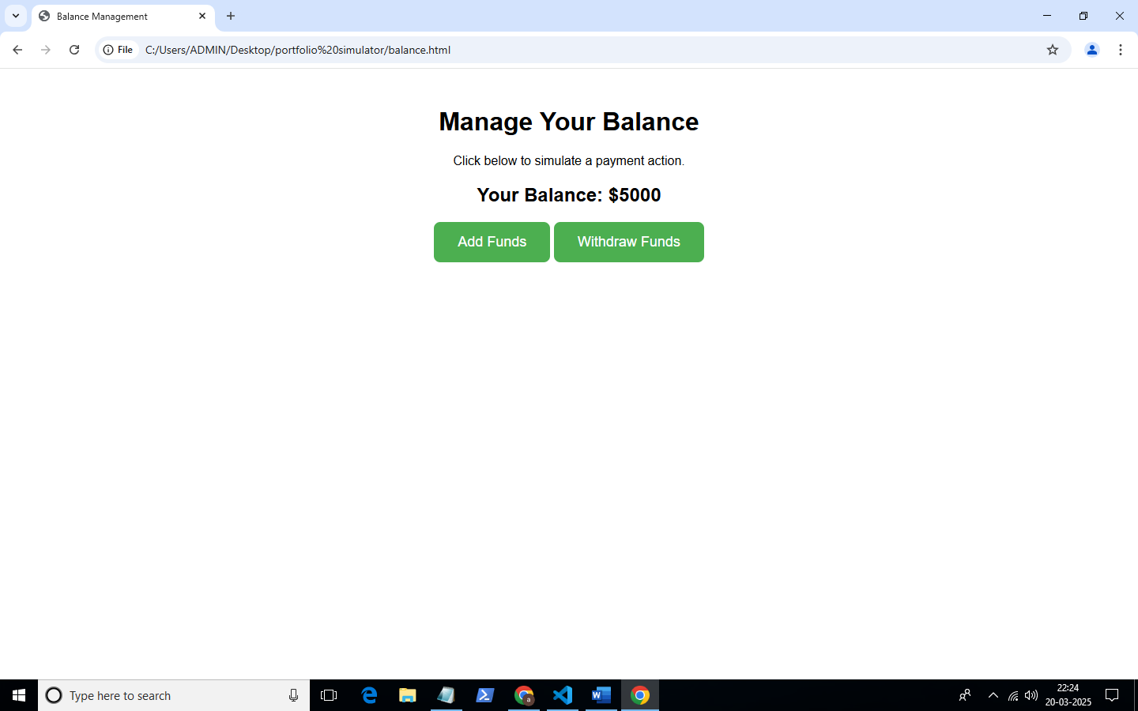

GitHub Repository Link: [[github](https://github.com/aishu71997/portfolio-simulator)]

Hosted Application Link[: [vercel]](https://vercel.com/aishu71997s-projects?projectDeleted=portfolio-simulator)